I’ve created a number of blog tutorials on the subject of creating maps in R.

Today, I’d like to share the package ‘usmap’ which enables incredibly easy and fast creation of US maps in R.

In honor of US Thanksgiving tomorrow, I’m going to make this blog Thanksgiving themed! In this tutorial, we will use the gTrendsR package to pull US Google search results on the keyword “thanksgiving” and plot the popularity by state.

**Set Up**

Identify which R packages we would like loaded. Check to see if the packages are installed, install if needed and load packages.

#Specify the packages of interest

packages = c("gtrendsR","tidyverse","usmap")

#Use this function to check if each package is on the local machine

#if a package is installed, it will be loaded

#if any are not, the missing package(s) will be installed and loaded

package.check <- lapply(packages, FUN = function(x) {

if (!require(x, character.only = TRUE)) {

install.packages(x, dependencies = TRUE)

library(x, character.only = TRUE)

}

Set a specific color variable for the upcoming maps

orange <- "#C9592E"

**Get Thanksgiving Trends**

Use the gTrendsR package to obtain the query trends for thanksgiving in the US for the past 24 hours

thanksgiving <- gtrends("thanksgiving",geo = "US", time = "now 1-d")

**Gather Interest by State**

Select the data frame which holds the keyword interest by state and then convert the names of the states to FIPS codes (2 characters for the state, 5 characters for the county) using the fips() function.

thanksgivingStates <- thanksgiving$interest_by_region

thanksgivingStates$fips <-fips(thanksgivingStates$location)

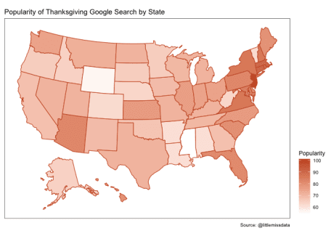

**Plot “thanksgiving” interest by state**

Create a US heatmap using the usmap package to plot Google search popularity for the keyword “thanksgiving”. We can clearly see from the graph below, how excited the east coast has been for thanksgiving in the past 24 hours. New Jersey is the winning state with Massachusetts, Connecticut,   
Rhode Island and New York following closely behind!

plot_usmap(data = thanksgivingStates, values = "hits", color = orange, labels=FALSE) +

scale_fill_continuous( low = "white", high = orange,

name = "Popularity", label = scales::comma

) +

theme(legend.position = "right") +

theme(panel.background = element_rect(colour = "black")) +

labs(title = "Popularity of Thanksgiving Google Search by State", caption = "Source: @littlemissdata")

**Plot “thanksgiving” interest for select states**

Drill in on the seemingly most popular regions using the “include” parameter in the plot_usmap() function.

plot_usmap(data = thanksgivingStates, values = "hits", include = c(.south_atlantic, .mid_atlantic, .new_england ), color = orange, labels=TRUE) +

scale_fill_continuous( low = "white", high = orange,

name = "Popularity", label = scales::comma

) +

theme(legend.position = "right") +

theme(panel.background = element_rect(colour = "black")) +

labs(title = "US East Coast Popularity of Thanksgiving Google Search", caption = "Source: @littlemissdata")

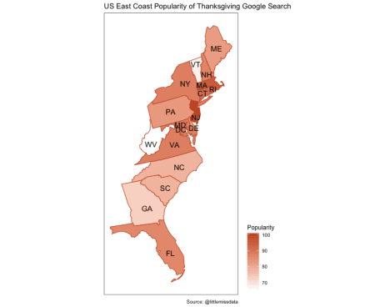

**Thank You**

Thank you for following along on our Thanksgiving themed map tutorial. Please comment below if you enjoyed this blog, have questions, or would like to see something different in the future.